
Holy Cross College

Semester 2 Examination 2019

Answer Booklet

Please place your student identification label in this box
Year 10 Science
(Adjusted)

Student Name
Student’s Teacher

Time allowed for this paper

Reading time before commencing work: 5 minutes
Working time for paper: 60 minutes

Materials required/recommended for this paper

To be provided by the supervisor

This Question/Answer Booklet
Data Sheet

To be provided by the candidate

Standard items: pens, pencils, eraser, correction fluid, ruler, highlighters.
Special items: non-programmable calculators satisfying the conditions set by the School Curriculum and Standards Authority for this course.

Important note to candidates

No other items may be taken into the examination room. It is your responsibility to ensure that you do not have any unauthorised notes or other items of a non-personal nature in the examination room. If you have any unauthorised material with you, hand it to the supervisor before reading any further.

Structure of this paper

Section | Number of questions available | Number of questions to be answered | Suggested working time  (minutes) | Marks available | Percentage of exam
Section One:  Multiple Choice | 18 | 18 | 20 | 18 | 45
Section Two:  Short Answer | 8 | 8 | 30 | 22 | 55
Section Three:  Comprehension | - | - | - | - | -
 |  |  |  | 40 | 100

Instructions to candidates

1. The rules for the conduct of examinations at Holy Cross College are detailed in the College Examination Policy. Sitting this examination implies that you agree to abide by these rules.

2. Write your answers in this Question/Answer Booklet.

3. Working or reasoning should be clearly shown when calculating or estimating answers.

4. You must be careful to confine your responses to the specific questions asked and to follow any instructions that are specific to a particular question.

5. Spare pages are included at the end of this booklet. They can be used for planning your responses and/or as additional space if required to continue an answer.

• Planning: If you use the spare pages for planning, indicate this clearly at the top of the page.
• Continuing an answer: If you need to use the space to continue an answer, indicate in the original answer space where the answer is continued, i.e. give the page number.
• Fill in the number of the question(s) that you are continuing to answer at the top of the page.

SECTION 1 MULTIPLE CHOICE (18 marks)

Make a choice of answer and write it in the box provided.

1. Compared to cold water, warm water:
QUESTION | ANSWER
1
2
3
4
5
6
7
8
9
10
11
12
13
14
15
16
17
18

(a) moves down away from the surface of the ocean.
(b) is dense.
(c) is heavy.
(d) moves up towards the surface of the ocean.

2. The ocean is becoming more acidic because:

(a) it is absorbing more atmospheric carbon dioxide.
(b) deforestation allows more acidic minerals to flow into the water.
(c) the melting ice caps are full of weak acids.
(d) fish and marine life are dying and decomposing due to climate change.

3. What is the name of the part of the hydrosphere that is made up of frozen water?

(a) icecaps
(b) icosphere
(c) permafrost
(d) cryosphere

4. The most damaging effect of the permafrost melting would be:

(a) having nowhere to ski anymore.
(b) sea levels rising due to the extra water.
(c) massive changes to the world’s tides.
(d) the release of large amounts of carbon into the atmosphere.

5. The biosphere is not made up of:

(a) bacteria.
(b) plants.
(c) animals.
(d) asteroids.

6. In which of Earth’s spheres is the most oxygen stored?

(a) hydrosphere
(b) atmosphere
(c) biosphere
(d) lithosphere

7. The most common gas in the atmosphere is:

(a) nitrogen.
(b) carbon dioxide.
(c) oxygen.
(d) hydrogen.

8. The crust of the Earth is broken into a number of pieces called:

(a) tectonic plates.
(b) boundaries.
(c) continents.
(d) ridges.

9. Acceleration is defined as:

(a) the rate of change of force.
(b) the rate of change of displacement.
(c) the rate of change of distance.
(d) the rate of change of velocity.

10. A decreasing rate of change of velocity could be called:

(a) positive acceleration.
(b) negative velocity.
(c) deceleration.
(d) braking.

11. In the absence of air resistance:

(a) heavier objects would accelerate toward the ground faster than lighter ones.
(b) more streamlined objects would accelerate toward the ground faster than less streamlined ones.
(c) all objects regardless of mass would accelerate toward the ground with the same velocity.
(d) objects with more mass would accelerate toward the ground faster than objects with less mass.

12. What is the acceleration of a car if it increases its velocity from 5.00 m/s to 15.0 m/s in
4.00 s? (Hint: Use a, v, u, t.)

(a) 2.50 m/s²
(b) 2.50 m/s
(c) 150 m/s²
(d) 5.20 m/s²

13. A balloon is inflated. When released, it rapidly speeds up and flies around. Which of the following best describes the force that causes the balloon’s motion?

(a) The push of the air in the room on the escaping air.
(b) The push of the escaping air on the air in the room.
(c) The push of the balloon on the escaping air.
(d) The push of the escaping air on the balloon.

14. You are watching a video of a passenger standing in a tram. Suddenly the passenger topples backwards. Which of the following best describes the motion of the tram at this moment?

(a) The tram starts moving forward.
(b) The tram starts moving backward.
(c) The tram is moving forwards and it starts to slow down.
(d) The tram is moving backwards and it starts to speed up.

15. An object accelerates at 2.5 m/s² under a nett force of 20 N. What is the mass of the object?
(Hint: Use F, m, a triangle.)

(a) 0.25 kg
(b) 6.0 kg
(c) 8.0 kg
(d) 50 kg

16. The tendency of an object to resist changes in its motion is called:

(a) inertia.
(b) weight.
(c) friction.
(d) work.

17. Newton’s Law, known as the Law of Inertia, is:

(a) his first law.
(b) his second law.
(c) his third law.
(d) none of the above.

18. An object has a mass of 250 kg. On Earth, it would have a weight closest to:
(Hint: Use F_{w}, m, g triangle.)

(a) 2.5 N.
(b) 25 N.
(c) 250 N.
(d) 2500 N.

END OF SECTION 1

SECTION 2 SHORT ANSWER (22 marks)

Attempt all questions. Write your answers in the spaces provided.

1. What are the Earth’s four major spheres? (2 marks)

•

•

•

•

2. Give three negative effects of melting sea ice. (3 marks)

•

•

•

3. Give two ways in which humans have contributed to the enhanced greenhouse effect. (2 marks)

•

•

4.
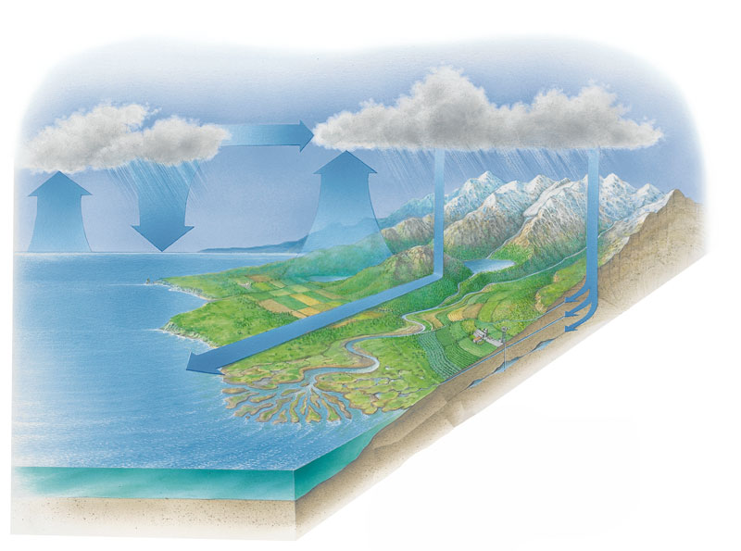

On the diagram above, list the main stages of the water cycle. (4 marks)

5. A train accelerates from rest at Whitfords Station and accelerates towards Greenwood station, reaching 35 m/s after 24 s. What is the train's acceleration?
(Hint: Use v, u, a, t.) (3 marks)

6. A force of 36 N acts on a mass of 24 kg. What is the acceleration of the mass?
(Hint: Use F, m, a triangle.) (3 marks)

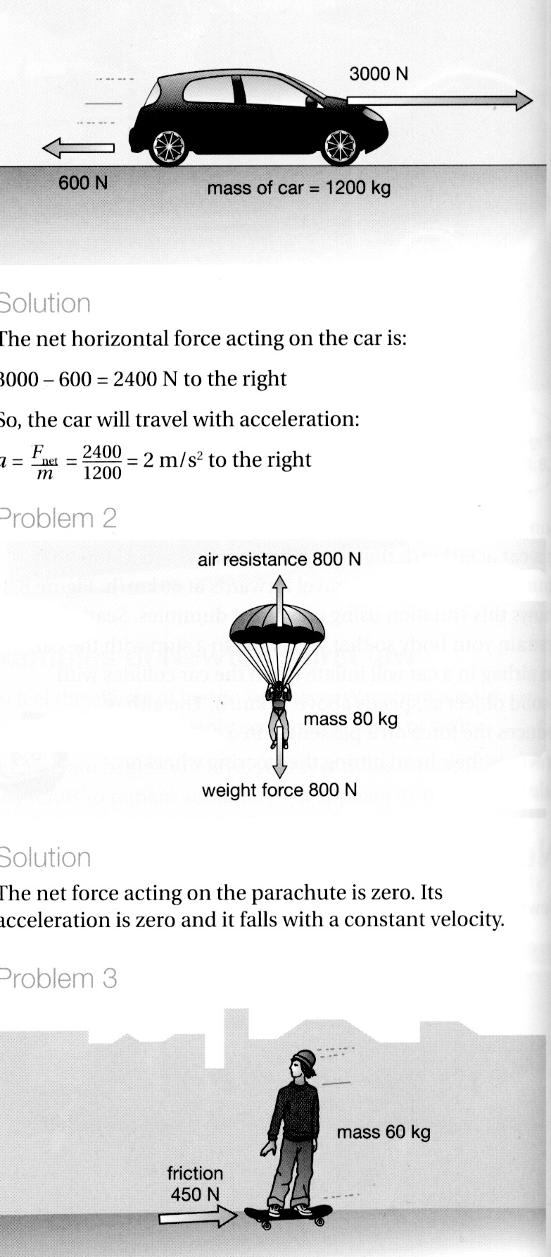
7. Consider the forces acting on the car in the diagram. Calculate the nett force acting on the car. (2 marks)

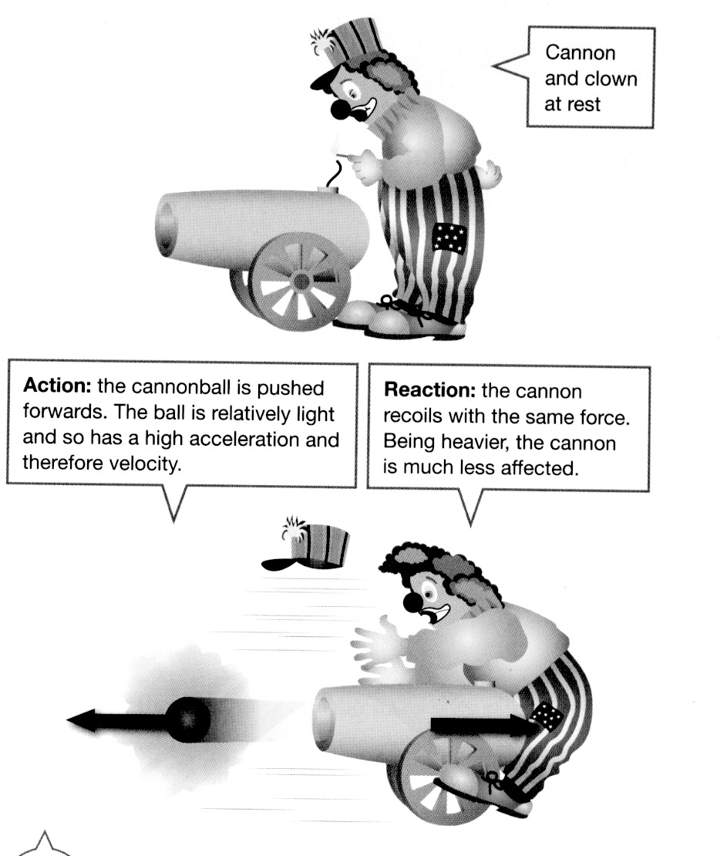
6. Look at the diagram showing a clown and a cannon at a circus.

(a) Which of Newton's three laws applies to this situation? (1 mark)

(b) Explain clearly why the cannon hits the clown. (2 marks)

